**BLOOD BANK MANAGEMENT SYSTEM**

Team Lead: V. JudsonSam

Group Members: J. Ashwini

Bhavya V Kumar P. Kanimozhi

I. Shivani

Y. Phanindra

**Table of Contents Page no**

1. INTRODUCTION………………………………………………………………………1
   1. Existing System
   2. Problem Definition
   3. Why we need a new system
2. SYSTEM REQUIREMENTS…………………………………………………………2
   1. Software Specification
   2. Hardware Specification
3. PROPOSED SYSTEM………………………………………………………………….3
   1. Advantages of proposed system

4. LIST OF IMPACTED MODULES……………………………………………………4

4.1 Login Admin Page

4.2 Admin Home Page

* 1. Add New Donor

4.4 Edit and Delete Donor Details

* 1. Search Donor By Blood Group

5. UML DIAGRAMS……………………………………………………………………..10

5.1 Usecase Diagram

5.2 Activity Diagram

5.3 Sequence Diagram

5.4 Donor Table Description

6. CONCLUSION……………………………………………………………………………14

7. REFERENCES…………………………………………………………………………….15

**Abstract**

Blood Bank Management System (BBMS) is a browser based system that is designed to store, process, retrieve and analyse information concerned with the administrative and inventory management within a blood bank. This project aims at maintaining all the information pertaining to blood donors, different blood groups available in the blood bank and help them manage in a better way. Aim is to provide transparency in this field, make the process of obtaining blood from a blood bank hassle free and reliable and hence make the system of blood bank management effective The donors who are interested in donating blood has to register in the database.

**1. INTRODUCTION**

The population of the world is multiplying with each coming year and so are the diseases and health issues. With an increase in the population there is an increase in the need of blood. The growing population of the world results in a lot of potential blood donors. But in spite of this not more than 10% of the total world population participate in blood donation. With the growing population and the advancement in medical science the demand for blood has also increased.

Due to the lack of communication between the blood donors and blood recipients, most of the patients in need of blood do not get the blood on time and hence lost their lives. There is dire need of synchronisation between the blood donors and hospitals and blood banks. Improper communication synchronisation between blood banks and hospitals leads to waste of blood available. These problems can dealt with by automatic the existing manual blood bank management system. A high-end efficient, highly available system has to be developed to bridge the gap between the donors and recipients and to reduce the efforts required to search for the blood donors.

**1.1** **Existing System**

Existing system of blood bank management is done manually. All the details including his blood group, medical reports, contact number and other personal details are collected from the donor and it is documented. All these paper works are stored for future reference. If an emergency arrives the administrator has to search for the appropriate donor from this huge collection of data.

**1.2** **Problem Definition**

Entering the details about the blood groups, members, addresses etc and tracking the database is complicated when the details are maintained manually. This makes the maintenance of scheduled erroneous.

**1.3** **Why we need a new system**

The existing system has the following disadvantages.

1. It is very time consuming.
2. It consumes a lot of manpower to better results.
3. lack of data security.
4. It takes a lot of time for the retrieval of data.
5. The percentage of accuracy is less.

To overcome all these limitations we propose a new system of blood bank management.

**2. SYSTEM REQUIREMENTS**

All computer software needs certain hardware components or other software resources to be present on a computer. These prerequisites are known as system requirements and often used as the guide line as opposed to an absolute rule.

**2.1 Software Specifications**

Operating System: Windows 8+.

Web Technologies: HTML, CSS.

Java/J2EE Technologies: JDBC, JSP.

Database: MySQL.

Server: Apache Tomcat Server 8.5.

**2.2 Hardware Specifications**  
Processor : i3/i5 Processor.  
RAM : 4/8GB.  
ROM : 250GB.

**3. PROPOSED SYSTEM**

The proposed Blood Bank management system helps the people who are in need of a blood by giving them all details of blood group availability or regarding the donors with the same blood group.

**3.1 Advantages of the proposed system:**

The proposed system helps the hospital administration to store the details of blood donors and effectively retrieve it in cases of emergency. This application saves the time as the Data is retrieved quickly when compared to the existing system where admin have to search for the record manually. Therefore time management is the main advantage .This application also helps to store the data more accurate and so it is more reliable. The benefit of this system is the filtering of donors on specific blood groups. For instance when blood is needed in an operation theatre and there is very less time to get the blood available so if we get the information like who can give blood in time, a life is saved**.**

**4. LIST OF IMPACTED MODULES**

1. Login Admin Page
2. Admin Home Page
3. Add New Donor
4. Edit and Delete Donor Details
5. Search Donor By Blood Group

**Login Admin Page:**

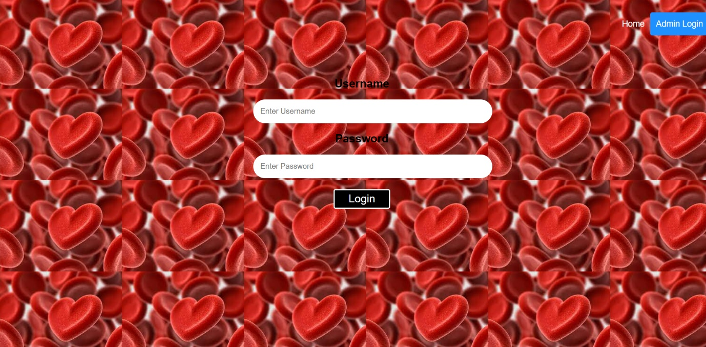

This is the page where admin can use his user name and password to login.

**Admin Home Page:**

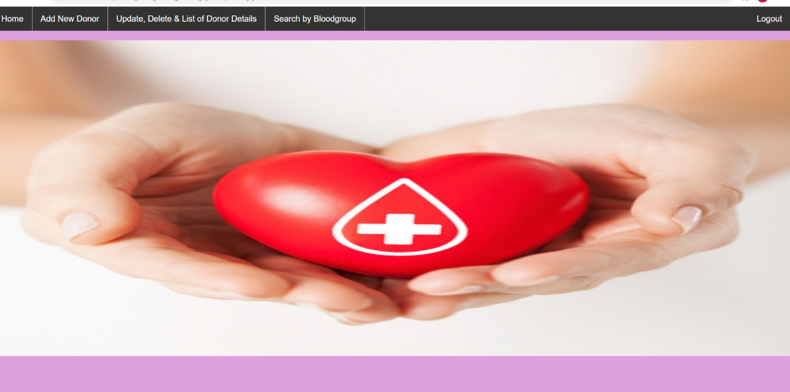

This is the home page where the admin can select the options :

1. **Home**- Returns to the home page.
2. **Add new donor**- Adding the details of new donor.
3. **Update, Delete & List of Donor Details**- Editing and view the details of a donor.
4. **Search By Blood Group**- Searching the donor details for a particular blood group.

**Add new donor:**

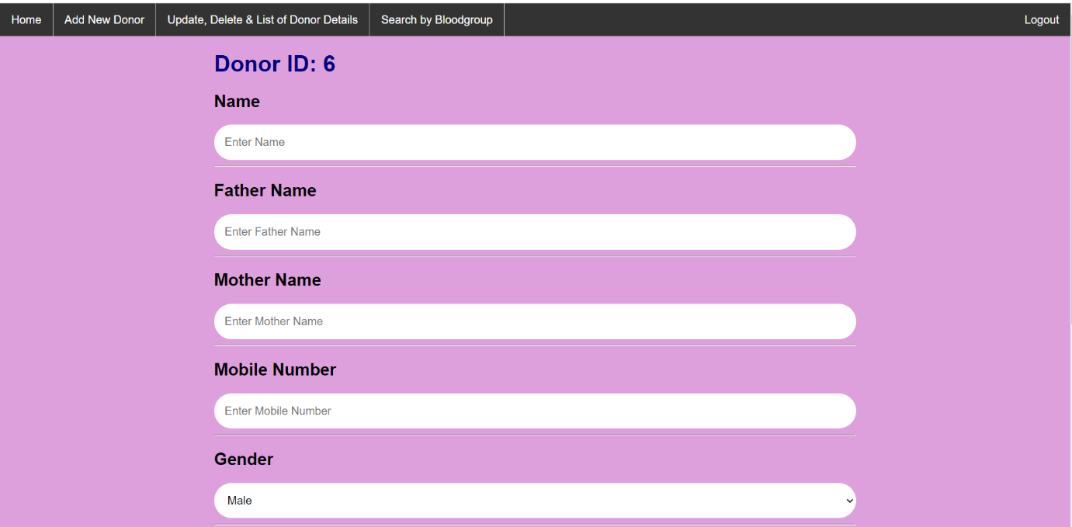

This page is used for adding the details of a donor.

**Edit and Delete Donor Details:**

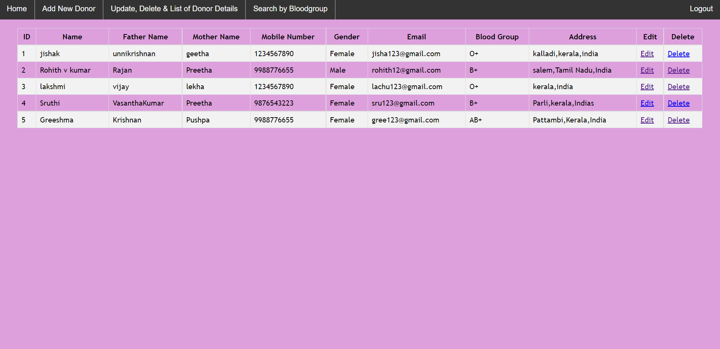

This page is used to view and edit the donor details.

**Search Donor By Blood Group:**

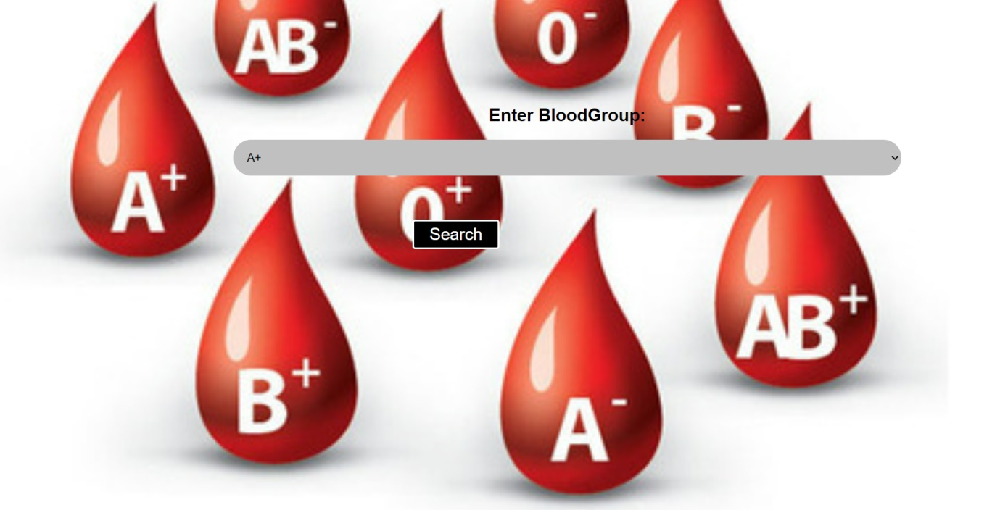

This page is used to find the donor according to particular blood groups.

**5. UML DIAGRAMS**

**5.1 Usecase Diagram**

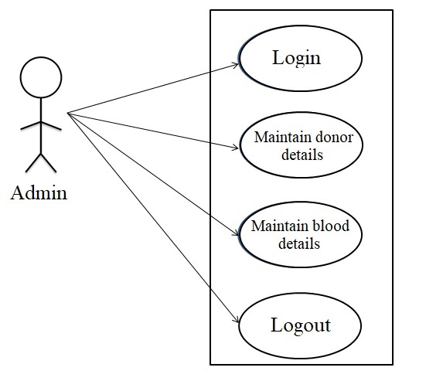

**5.2 Activity Diagram**

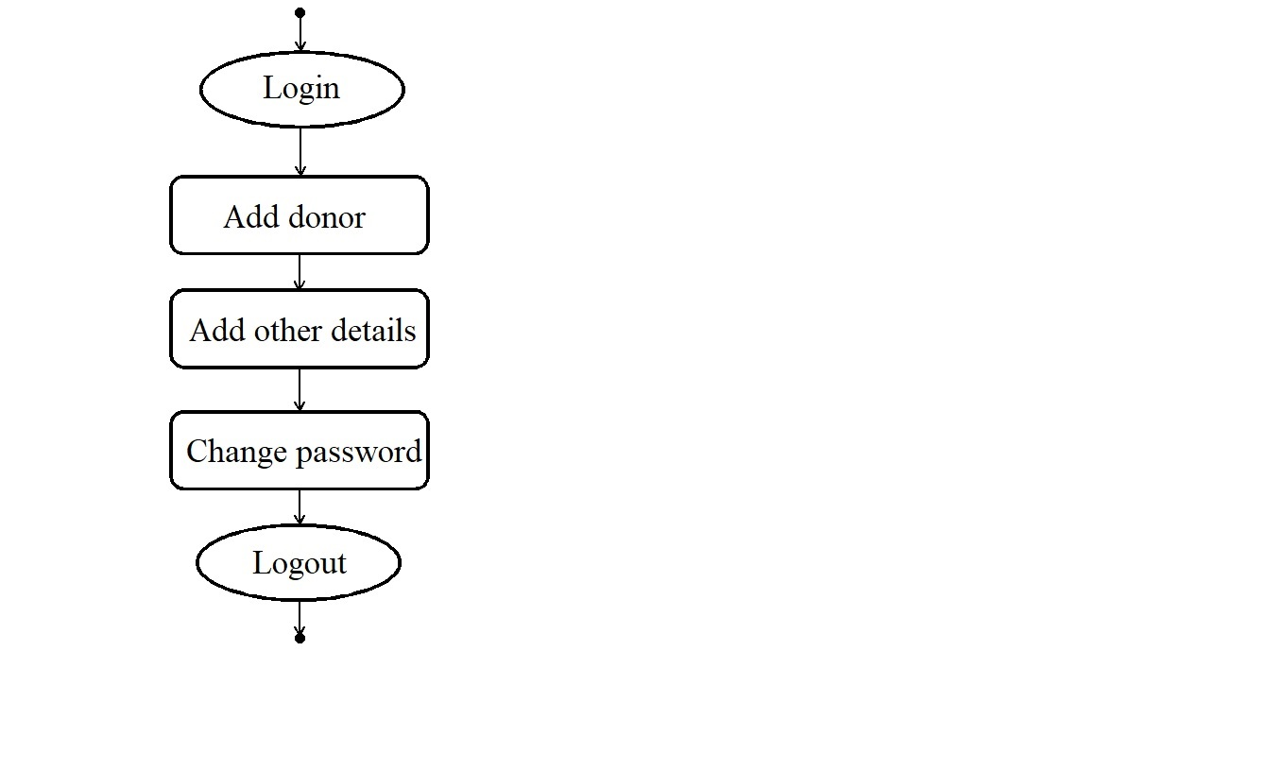

**5.3 Sequence Diagram**

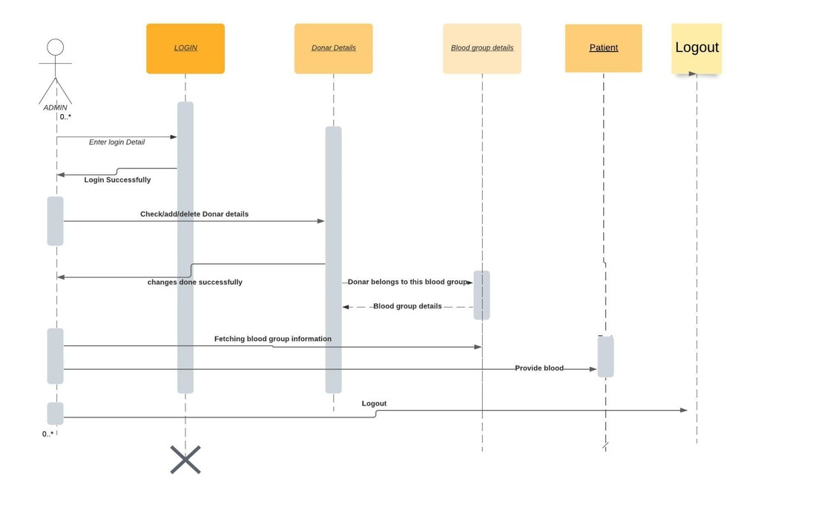

**5.4 Donor Table Description**

|  |
| --- |
| Donor |
| integer id  varchar name  varchar father  varchar mother  integer mobilenumber  varchar gender  varchar email  varchar bloodgroup  varchar address |

**6.CONCLUSION**

Technology is introducing new innovations day by day, thus reducing the time required to do things. The blood bank management system can be used to reduce the time required to deliver required blood to the needy in cases of emergency. The web application that we developed can be used by the administrator to search the donors by their blood group in cases of emergencies easily. The admin can also add, edit, delete or view the donor details using the application.

**REFERENCES**

[**https://sites.google.com/site/ignoubcafinalyearprojects/project-report/blood-bank-management-system-project-report**](https://sites.google.com/site/ignoubcafinalyearprojects/project-report/blood-bank-management-system-project-report)

[**http://ignousupport.blogspot.com/p/blood-bank-management-system-project.html**](http://ignousupport.blogspot.com/p/blood-bank-management-system-project.html)

[**https://www.researchgate.net/publication/339032343_Blood_bank_and_Donor_Management_system**](https://www.researchgate.net/publication/339032343_Blood_bank_and_Donor_Management_system)

[**https://www.w3schools.com**](https://www.w3schools.com)